**Mini-Sentinel Distributed Query Tool**

**Summary Table Descriptions**

Version 1.4

**January 2013**

**CONTACT:**

Mini-Sentinel Operations Center

Harvard Pilgrim Health Care Institute

[info@mini-sentinel.org](mailto:info@mini-sentinel.org)

Contents

1. Query Tool Overview 1

2. Summary Table Overview 1

3. Definitions 1

4. Description of Summary Tables 3

a. Age Groups Table 3

b. Enrollment Summary Table 3

c. ICD-9-CM Diagnosis Summary Table (3 digit) 4

d. ICD-9-CM Diagnosis Summary Table (4 digit) 5

e. ICD-9-CM Diagnosis Summary Table (5 digit) 7

f. HCPCS Summary Table 8

g. ICD-9-CM Procedure Summary Table (3 digit) 9

h. ICD-9-CM Procedure Summary Table (4 digit) 10

i. Ingredient Name Summary Table 11

j. Drug Category Summary Table 13

k. Incident ICD-9-CM Diagnosis Summary Table (3 Digit) 14

l. Incident Drug Category Summary Table 15

m. Incident Ingredient Name Summary Table 16

5. Most Frequent Utilization Feature 17

6. Query Result Denominator 18

# 

**Document History**

The following table is a revision history for this document.

**Table 1: Document History**

|  |  |  |  |
| --- | --- | --- | --- |
| **Revision** | **Author(s)** | **Date** | **Description** |
| 1.0 | Jeff Brown | 2/21/2011 | Created |
| 1.1 | Jeff Brown, Elizabeth Balaconis, Megan Mazza | 4/22/2011 | Text edits for release to Data Partners. Posted to public website and query tool. |
| 1.2 | Jeff Brown, Elizabeth Balaconis, Megan Mazza, Nicolas Beaulieu | 8/14/2012 | Revised definition of ‘member’. Added description of incident and most frequent utilization queries. Defined the new Age Group table (section 4a). Added ‘DaysCovered’ and ‘Stratum’ to definitions in Section 3. Removed ‘U’ from ‘Sex’ column. Various text edits for clarity. Posted to public website and query tool. |
| 1.3 | Jeff Brown, Elizabeth Balaconis, Megan Mazza, Nicolas Beaulieu, Lisa Trebino | 11/26/12 | Added the section about the Most Frequent Utilization feature |
| 1.4 | Jeff Brown, Elizabeth Balaconis, Megan Mazza | 1/10/2013 | Added updated language to the prevalence query section. Added the query result denominator section |

# 1. Query Tool Overview

The Mini-Sentinel Distributed Query Tool is designed to facilitate distributed querying within the Mini-Sentinel network. It is based on the PopMedNetTM software application ([www.popmednet.org](http://www.popmednet.org)). The Mini-Sentinel Distributed Query Tool allows simple and rapid menu-driven querying of pre-populated summary tables. The following sections describe the structure of the summary tables that are currently supported by the Mini-Sentinel Distributed Query Tool software.

Each Data Partner must install the Mini-Sentinel Distributed Query Tool software, establish a network connection using the Mini-Sentinel Distributed Query Tool secure web-based portal, and use the application to respond to queries sent by Mini-Sentinel Operations Center staff on behalf of the FDA.

# 2. Summary Table Overview

The system supports three broad query types: prevalent queries, incident queries, and most frequent utilization queries. The nine prevalence summary tables represent prevalence counts of diagnoses (3, 4, and 5 digit ICD-9-CM), procedures (3 and 4 digit ICD-9-CM and HCPCS), drug exposures (ingredient name and drug category), and enrollment. The three incidence summary tables represent diagnoses (3-digit ICD-9-CM) and drug exposures (ingredient name and drug category). The most frequent utilization queries return the most frequently observed utilization (drug exposures, diagnoses, or procedures) defined by events or number of users by age group, sex, and year within the prevalence tables.

The tables are described below. The summary tables are created through distributed SAS programs written by the Mini-Sentinel Operations Center and executed against the Mini-Sentinel Distributed Database held by each Data Partner. Each Data Partner is responsible for maintaining the summary tables behind their firewalls and responding to distributed queries using the Mini-Sentinel Distributed Query Tool software.

The code set used for the specifications for HCPCS, ICD-9-CM Diagnosis (3, 4 and 5 digit) and ICD-9-CM Procedure (3 and 4 digit) query types are provided by Ingenix, Inc. The query tool software uses the short name description, as opposed to the long name description, to match code names. The Mini-Sentinel Operations Center compiles a list of diagnosis and procedure codes unique to each Data Partner’s code availability.

# 3. Definitions

This section provides high-level concepts used in creating the summary tables. Details of each summary table are in the next section. Please contact the Mini-Sentinel Operations Center to discuss specific questions about definitions.

**Age Group**: The system uses the following age groups: 0-1, 2-4, 5-9, 10-14, 15-18, 19-21, 22-44, 45-64, 65-74, and 75+. Age is defined as the age as of the date of first utilization. For the enrollment table, age is defined as age at initial cohort eligibility during the period (e.g., age as of the start of coverage).

**Sex**: The system uses the following categories for sex: male and female.

**Member:** A member is defined as aperson who is cared for by the institution. For utilization counts a “member” is a person who received care. For enrollment, a member is a covered individual at any time during the period in question. A “member” is a health insurance concept referring to an individual for whom the insurer has some responsibility for reimbursement of their medical coverage during a defined period. Non insurer-based settings such as medical group practices should use a definition appropriate to their setting and document the definition.

**Days Covered:** Days covered is included in the Enrollment table. It represents the sum, by strata, of the totals days of enrollment for each member in the strata.

**Stratum:** A stratum is a combination of age, sex, period, and setting (if applicable). Each combination is presented in the result tables as a separate row, even if there are zero encounters. Denominators are pulled from the Enrollment table to get the relevant rates across participating Data Partners.

**Event Counts:** Counts of events for pharmacy dispensing (*i.e.,* dispensing) and medical utilization (*i.e.,* visits) are derived from the relevant utilization tables in the Mini-Sentinel Distributed Database. These counts are not restricted to health plan members; the counts represent all records observed in the database regardless of membership or medical or drug coverage status.

# 4. Description of Summary Tables

Each of the 13 tables available via the Mini-Sentinel Distributed Query Tool is described below.

## Age Groups Table

The age groups table provides a key for the age group stratifications within each summary table. This table provides a unique Age Group ID for one of the ten following age groups: ‘ 0-1’, ‘2-4’, ‘ 5- 9’, ’10-14’, ’15-18’, ’19-21’, ’22-44’, ’45-64’, ’65-74’ and ‘75+’. This table is used to minimize the complexity of the query created by the Mini-Sentinel Query Tool. The table is created as part of the distributed SAS code. The file will not change with each data refresh, but it must be held in the local summary table database at all times to enable the query process.

Summary table name: AGE_GROUPS

ID: Numeric format

StratXX_name: Character format

StratXX_sort_order: Numeric format

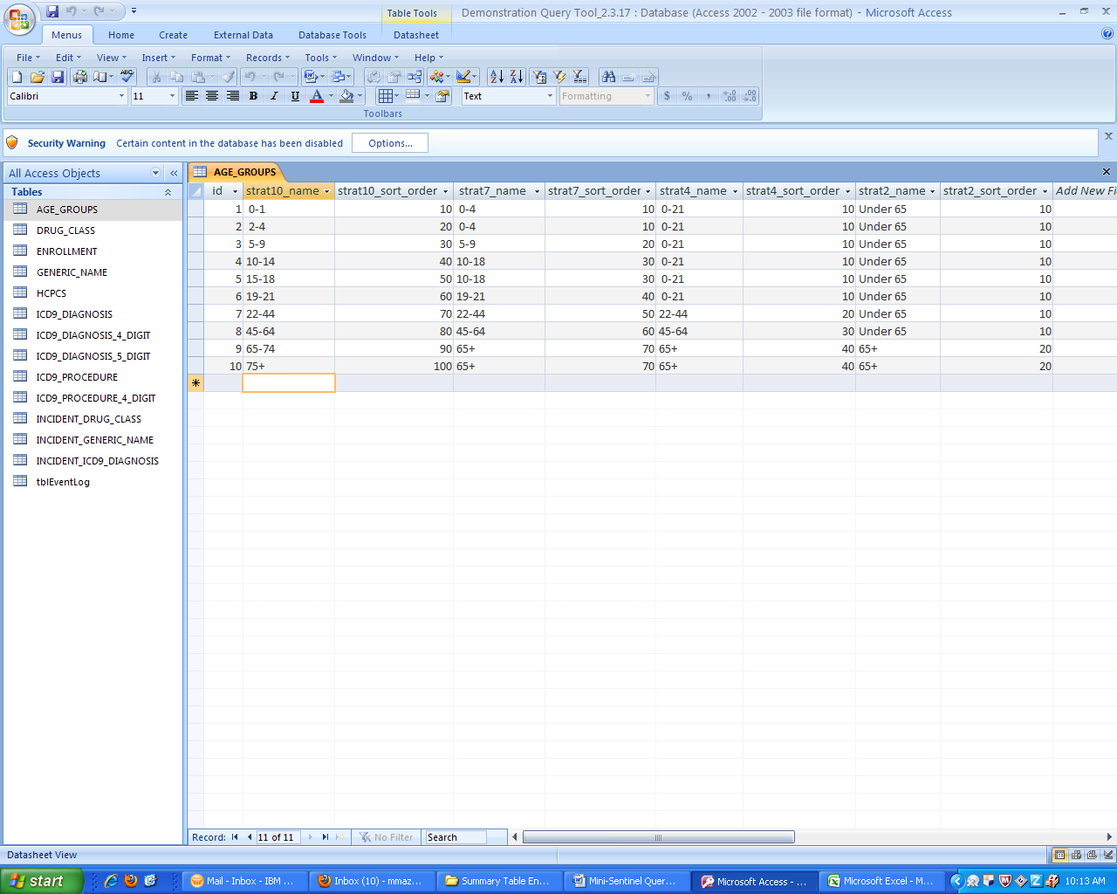

**Figure 1: Age Groups Table**

## Enrollment Summary Table

The enrollment table provides a count of unique members and days covered as defined above. The member count and days covered are stratified by age group, sex, year, drug coverage status and medical coverage status. The count of unique members or days covered can be used as denominators to calculate crude prevalence rates.

***Table name, variables, and permissible formats for the Enrollment table:***

Summary table name: ENROLLMENT

Age_Group: ‘ 0-1’, ‘2-4’, ‘ 5- 9’, ’10-14’, ’15-18’, ’19-21’, ’22-44’, ’45-64’, ’65-74’, ‘75+‘

Sex: ‘M’, ‘F’ (character format)

Year: 4 digit year (character format)

DrugCov: ‘Y’, ‘N’ (character format)

MedCov: ‘Y’, ‘N’ (character format)

Members: Numeric format

Days Covered: Numeric format

Age_Group_Id: Numeric format

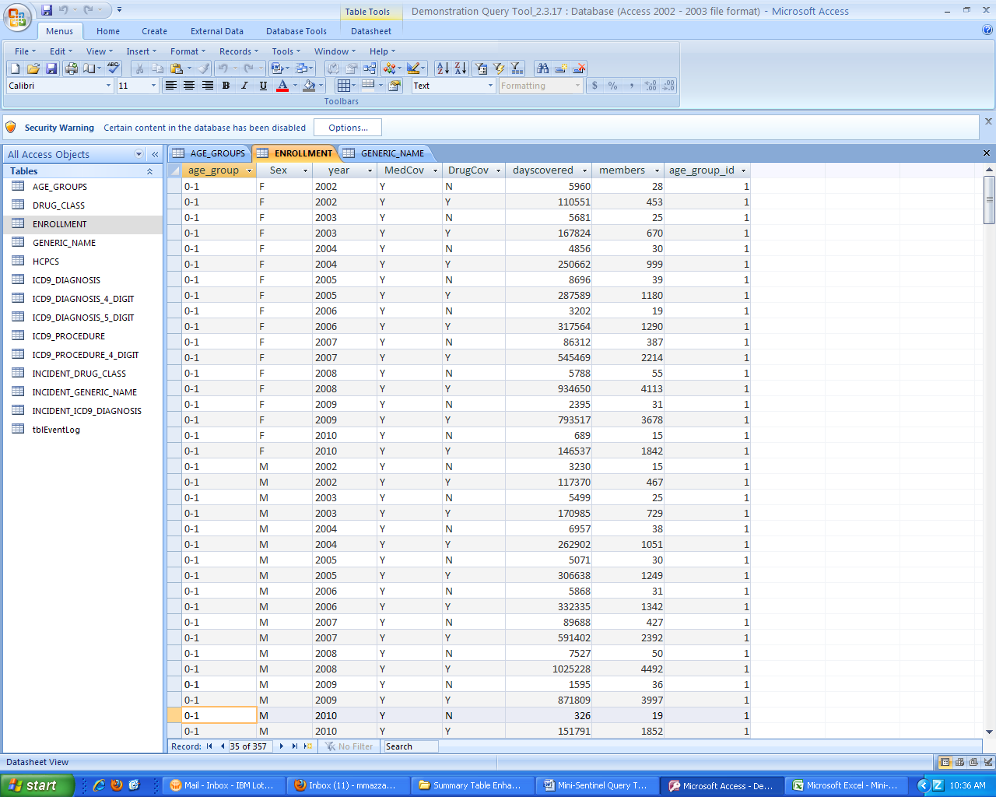

**Figure 2: Sample Enrollment Table**

## ICD-9-CM Diagnosis Summary Table (3 digit)

The 3 digit ICD-9-CM diagnosis table provides a count of unique members with a diagnosis observed during the period and a count of events experienced within each stratum.

The counts are stratified by setting of visit (inpatient, outpatient, emergency department, any), age group, sex, year, and 3 digit ICD-9-CM code. Members are categorized into visit setting by the encounter type: **inpatient** includes acute inpatient hospital stay and non-acute institutional stays; **emergency department** includes emergency department encounters; **outpatient** includes ambulatory visit, telephone encounters, email encounters and other outpatient encounters’; **Any** includes the members with a visit in any of the care settings. For instance, if a member has the same diagnosis code observed across multiple care settings during a period, the member will be counted once in the member count and all the visits with the code will be summed for the event counts.

***Table name, variables, and permissible formats for the 3-digit ICD-9-CM Diagnosis table:***

Summary table name: ICD9_DIAGNOSIS

Age_Group: ‘ 0-1’, ‘2-4’, ‘ 5- 9’, ’10-14’, ’15-18’, ’19-21’, ’22-44’, ’45-64’, ’65-74’, ‘75+ ‘ (character format)

Sex: ‘M’, ‘F’ (character format)

Period: 4 digit year (character format)

Code: 3 digit code XXX (character format)

DXname: 72 digit character format

Setting: ‘IP‘, ‘ED‘, ‘AV’, ‘AN’ (character format)

Members: Numeric format

Events: Numeric format

Age_Group_ID: Numeric format

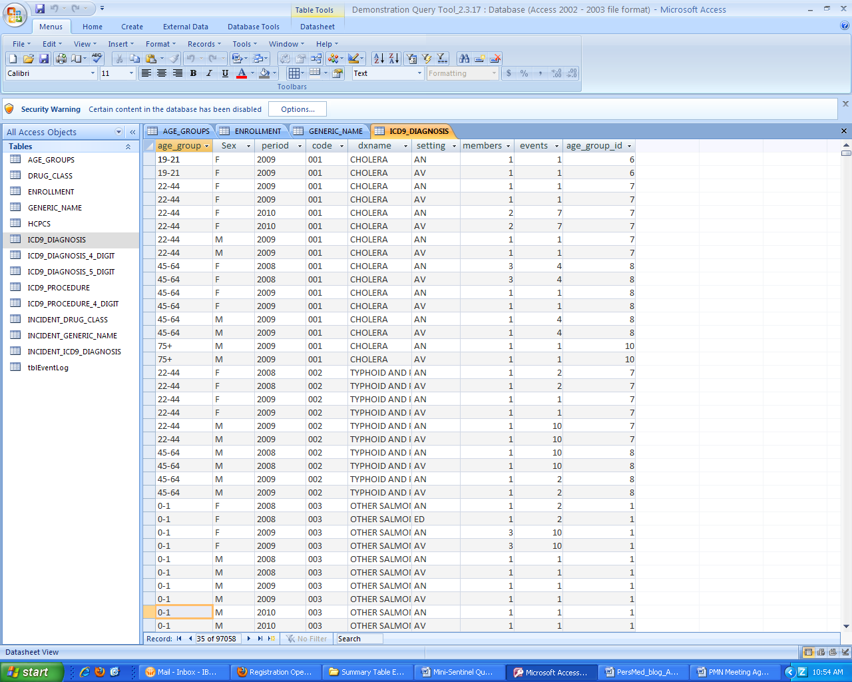

**Figure 3: Sample 3-Digit ICD-9-CM Diagnosis Table**

## ICD-9-CM Diagnosis Summary Table (4 digit)

The 4 digit ICD-9-CM diagnosis table provides a count of unique members with a diagnosis observed during the period and a count of events experienced within each stratum. The counts are stratified by setting of visit as described above (3-digit diagnosis summary tables).

***Table name, variables, and permissible formats for the 4 digit ICD-9-CM Diagnosis table:***

Summary table name: ICD9_DIAGNOSIS_4_DIGIT

Age_Group: ‘ 0-1’, ‘2-4’, ‘ 5- 9’, ’10-14’, ’15-18’, ’19-21’, ’22-44’, ’45-64’, ’65-74’, ‘75+‘ (character format)

Sex: ‘M’, ‘F’ (character format)

Period: 4 digit year (character format)

Code: 4 digit code XXXX (character format)

DXname: 72 digit character format

Setting: ‘IP‘, ‘ED‘, ‘AV’, ‘AN’ (character format)

Members: Numeric format

Events: Numeric format

Age Group ID: Numeric format

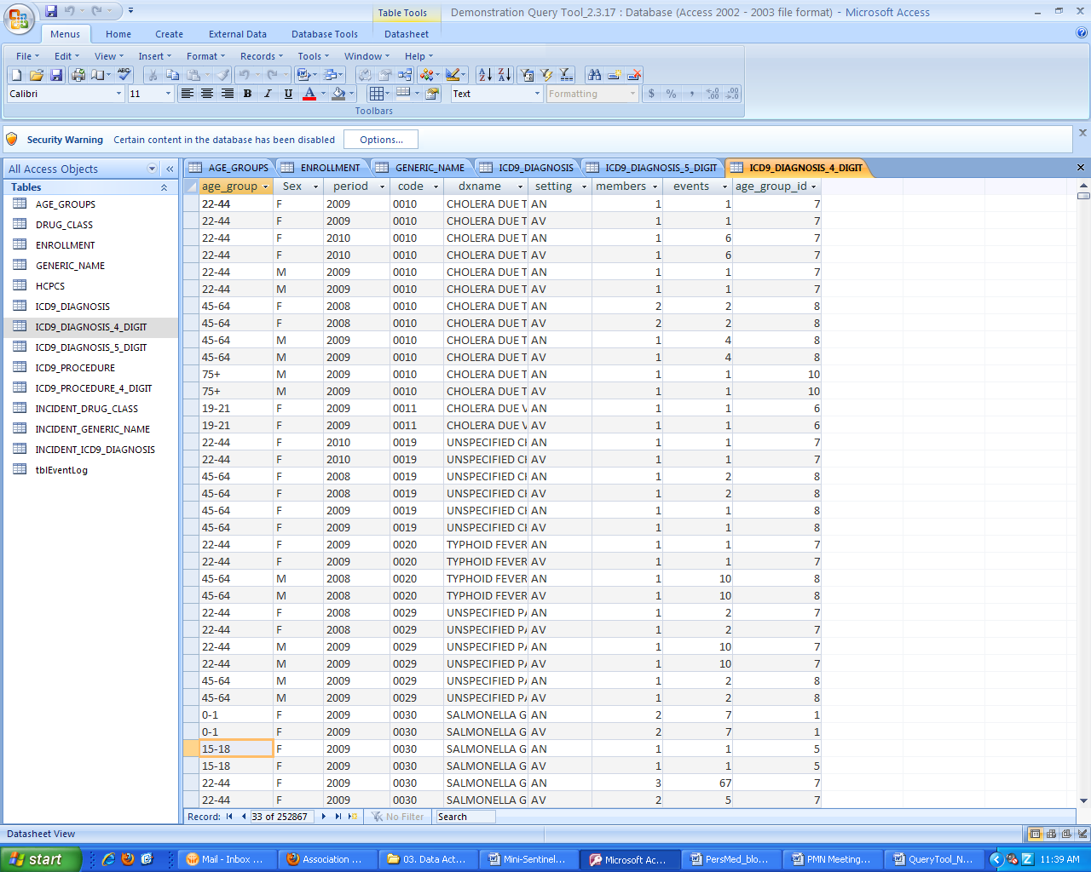

**Figure 4: Sample 4-Digit ICD-9-CM Diagnosis Table**

## ICD-9-CM Diagnosis Summary Table (5 digit)

The 5 digit ICD-9-CM diagnosis table provides a count of unique members with a diagnosis observed during the period and a count of events experienced within each stratum. The counts are stratified by setting of visit as described above (3-digit diagnosis summary tables).

***Table name, variables, and permissible formats for the 5 digit ICD-9-CM Diagnosis table:***

Summary table name: ICD9_DIAGNOSIS_5_DIGIT

Age_Group: ‘ 0-1’, ‘2-4’, ‘ 5- 9’, ’10-14’, ’15-18’, ’19-21’, ’22-44’, ’45-64’, ’65-74’, ‘75+‘ (character format)

Sex: ‘M’, ‘F’(character format)

Period: 4 digit year (character format)

Code: 5 digit code XXXXX (character format)

DXname: 72 digit character format

Setting: ‘IP‘, ‘ED‘, ‘AV’, ‘AN’(character format)

Members: Numeric format

Events: Numeric format

Age_Group_Id: Numeric format

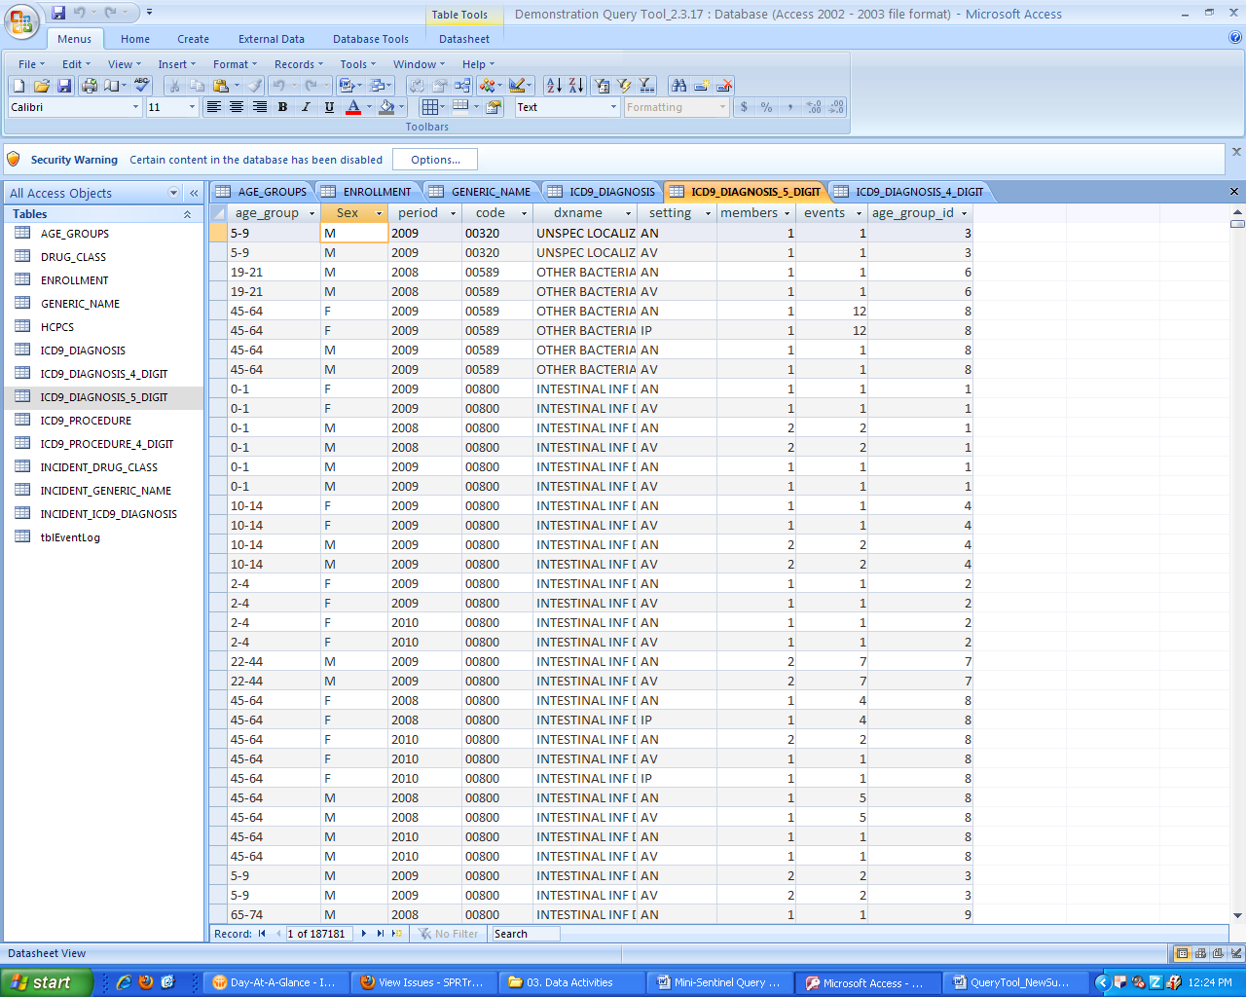

**Figure 5: Sample 5-Digit ICD-9-CM Diagnosis Table**

## HCPCS Summary Table

The HCPCS table provides a count of unique members who had a procedure observed during the period and a count of events experienced within each stratum.

The counts are stratified by setting of visit (as defined above), age group, sex, year, and HCPCS code. Members are categorized into visit setting as described above (3-digit diagnosis summary tables).

***Table name, variables, and permissible formats for the HCPCS Procedure table:***

Summary table name: HCPCS

Age_Group: ‘ 0-1’, ‘2-4’, ‘ 5- 9’, ’10-14’, ’15-18’, ’19-21’, ’22-44’, ’45-64’, ’65-74’, ‘75+ ‘ (character format)

Sex: ‘M’, ‘F’ character format)

Period: 4 digit year (character format)

Code: 5 digit code XXXXX (character format)

PXname: 72 digit character format

Setting: ‘IP‘, ‘ED‘, ‘AV’, ‘AN’ (character format)

Members: Numeric format

Events: Numeric format

Age_Group_Id: Numeric format

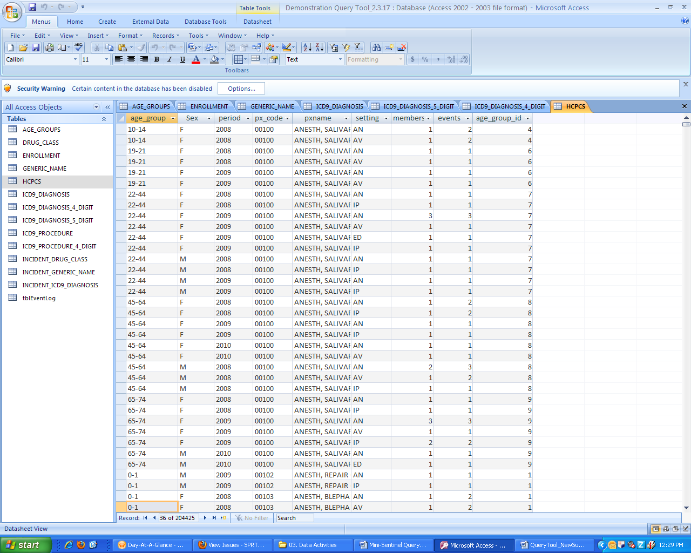

**Figure 6: Sample HCPCS Procedure Code Table**

## ICD-9-CM Procedure Summary Table (3 digit)

The ICD-9-CM 3 digit procedure table provides a count of unique members with an ICD-9-CM coded procedure observed during the period and a count of events in each stratum.

The counts are stratified by setting of visit (as defined above), age group, sex, year, and 3 digit ICD-9-CM procedure code (format XXX). Members are categorized into visit setting as described above (3-digit diagnosis summary tables).

***Table name, variables, and permissible formats for the ICD-9-CM Procedure table:***

Summary table name: ICD9_PROCEDURE

Age_Group: ‘ 0-1’, ‘2-4’, ‘ 5- 9’, ’10-14’, ’15-18’, ’19-21’, ’22-44’, ’45-64’, ’65-74’, ‘75+ ‘ (character format)

Sex: ‘M’, ‘F’ (character format)

Period: 4 digit year (character format)

Setting: ‘IP‘, ‘ED‘, ‘AV’, ‘AN’ (character format)

Code: 3 digit code XXX (character format)

PXname: 72 digit character format

Members: Numeric format

Events: Numeric format

Age_Group_ID: Numeric format

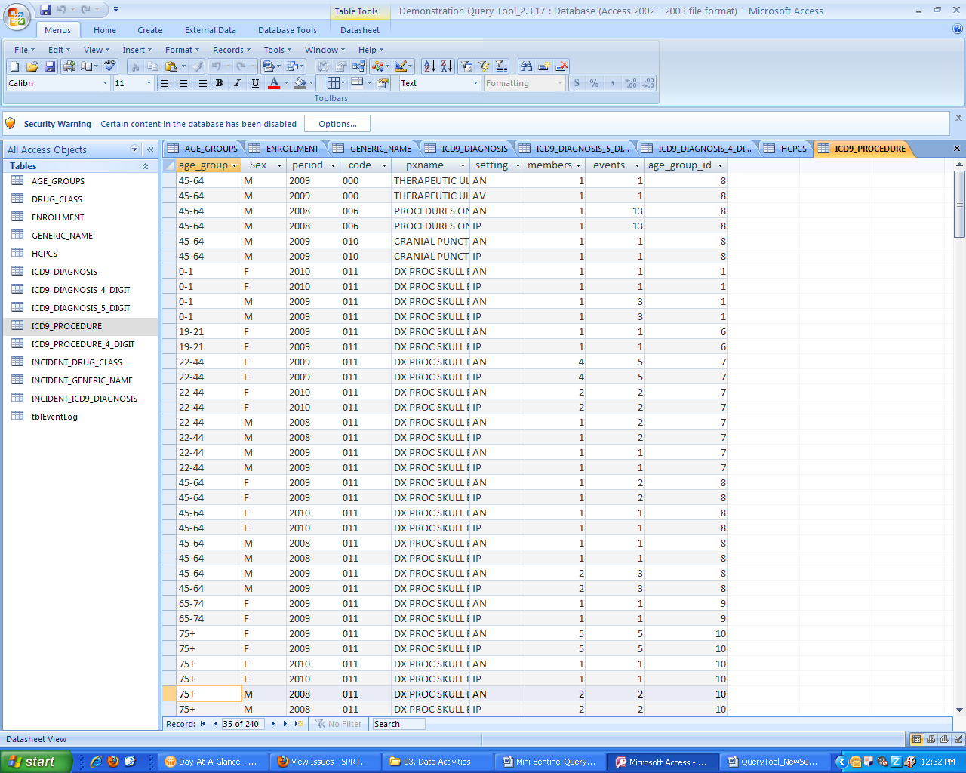

**Figure 7: Sample 3-Digit ICD-9-CM Procedure Code Table**

## ICD-9-CM Procedure Summary Table (4 digit)

The ICD-9-CM 4 digit procedure table provides a count of unique members with an ICD-9-CM coded procedure observed during the period and a count of events experienced within each stratum.

The counts are stratified by setting of visit (as defined above), age group, sex, year, and 4 digit ICD-9-CM procedure code (format XXXX). Members are categorized into visit setting as described above (3-digit diagnosis summary tables).

***Table name, variables, and permissible formats for the ICD-9-CM (4 digit) Procedure table:***

Summary table name: ICD9_PROCEDURE_4_DIGIT

Age_Group: ‘ 0-1’, ‘2-4’, ‘ 5- 9’, ’10-14’, ’15-18’, ’19-21’, ’22-44’, ’45-64’, ’65-74’, ‘75+ ‘ (character format)

Sex: ‘M’, ‘F’ (character format)

Period: 4 digit year (character format)

Setting: ‘IP‘, ‘ED‘, ‘AV’, ‘AN’ (character format)

PX_Code: 4 digit code XXXX (character format)

PXname: 72 digit character format

Members: Numeric format

Events: Numeric format

Age_Group_ID: Numeric format

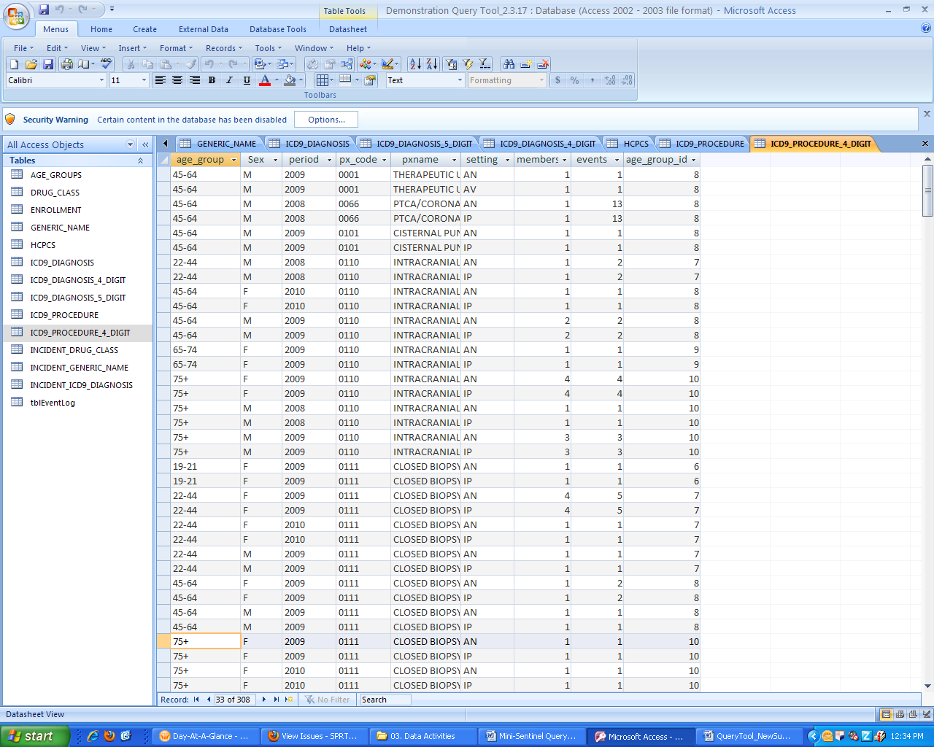

**Figure 8: Sample 4-Digit ICD-9-CM Procedure Code Table**

## Ingredient Name Summary Table

The ingredient name, also known as Generic Name, table provides a count of unique members who had a drug dispensing during the period, a count of dispensings received by all of these members, and total days supplied by strata.

The counts are stratified by generic drug name, age group, sex, quarter-year and year. The generic drug name is standardized using a look-up table provided by the Mini-Sentinel Operations Center.

***Table name, variables, and permissible formats for the Ingredient Name table:***

Summary table name: GENERIC_NAME

Age_Group: ‘ 0-1’, ‘2-4’, ‘ 5- 9’, ’10-14’, ’15-18’, ’19-21’, ’22-44’, ’45-64’, ’65-74’, ‘75+ ‘ (character format)

Sex: ‘M’, ‘F’ (character format)

Period: 4 digit year (character format)

GenericName: 72 digit character format

Members: Numeric format

Events: Numeric format

DaysSupply: Numeric format

Age_Group_ID: Numeric format

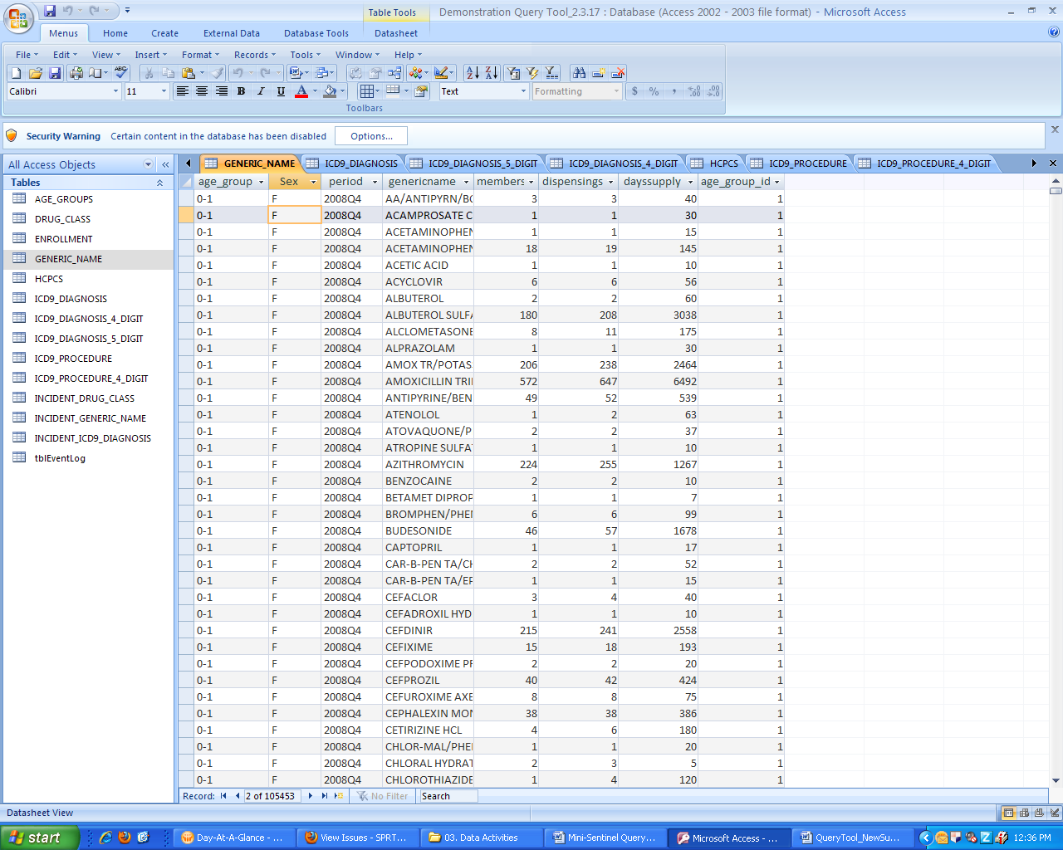

**Figure 9: Sample Ingredient Name Summary Table**

## Drug Category Summary Table

The drug category, also known as Drug Class, table provides a count of unique members who had a drug dispensing during the period and a count of dispensings received by all of these members by strata. Additionally, a count of total days supply (sum of days supply for all members by strata) is included.

The counts are stratified by drug class, age group, sex, quarter-year and year. The drug category is standardized using a look-up table provided by the Mini-Sentinel Operations Center.

***Table name, variables, and permissible formats for the Drug Category table:***

Summary table name: DRUG_CLASS_

Age_Group: ‘ 0-1’, ‘2-4’, ‘ 5- 9’, ’10-14’, ’15-18’, ’19-21’, ’22-44’, ’45-64’, ’65-74’, ‘75+ ‘ (character format)

Sex: ‘M’, ‘F’ (character format)

Period: 4 digit year (character format)

DrugClass: 72 digit character format

Members: Numeric format

Dispensings: Numeric format

DaysSupply: Numeric format

Age_Group_ID: Numeric format

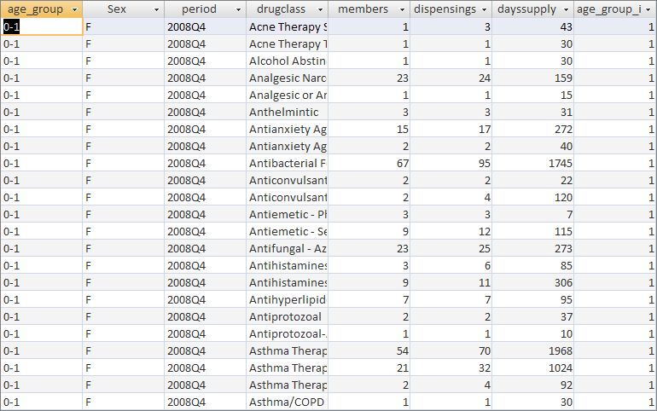

**Figure 10: Sample Drug Class Summary Table**

## Incident ICD-9-CM Diagnosis Summary Table (3 Digit)

The incident ICD-9-CM diagnosis table provides a count of unique members with an incident diagnosis of each 3-digit ICD-9-CM category in one of four care setting of interest (*i.e.*, inpatient, emergency department, ambulatory, and any) stratified by age group, sex, and year. Incidence is defined as a member with an encounter with the diagnosis of interest (*i.e.*, the index date), in the care setting of interest, in the year of interest with no evidence of that diagnosis in the 90, 180 and 270 days (*i.e.*, the lookback periods) before the index date in **any care setting.** Both medical and drug coverage are required during the 3 possible lookback periods, allowing for eligibility gaps of <=45 days. In addition, the tables also report number of encounters in the care setting of interest with that diagnosis in the 90, 180, 270 days after the index date (including the index event). Only the first incident event/index date within each year is considered.

Counts are stratified by setting of visit, age group, sex, year, 3 digit ICD-9-CM code(s) of interest. For each stratum the number of members and events for the 90, 180 and 270 lookback scenarios are reported.

***Table name, variables, and permissible formats for the 3-digit ICD-9-CM Diagnosis Incidence table:***

Summary table name: INCIDENT_ICD9_DIAGNOSIS

Age_Group: ‘ 0-1’, ‘2-4’, ‘ 5- 9’, ’10-14’, ’15-18’, ’19-21’, ’22-44’, ’45-64’, ’65-74’, ‘75+ ‘ (character format)

Sex: ‘M’, ‘F’ (character format)

Period: 4 digit year (character format)

Code_: 3 digit code XXX (character format)

DXname: 72 digit character format

Setting: ‘IP‘, ‘ED‘, ‘AV’, ‘AN’ (character format)

Members90: Numeric format

Events90: Numeric format

Members180: Numeric format

Events180: Numeric format

Members270: Numeric format

Events270: Numeric format

Age_Group_ID: Numeric format

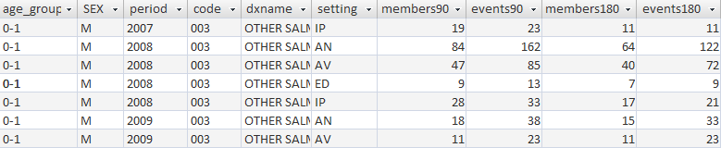

**Figure 11: Sample Incident 3-Digit ICD-9-CM Diagnosis Summary Table**

## Incident Drug Category Summary Table

The incident drug category table provides a count of unique members with an incident dispensing for each drug category (e.g., betablocker, antidiabetic) of interest stratified by age group, sex, and year. Incidence is defined as a member with a dispensing with the drug category of interest (i.e., the index date), in the year of interest with no evidence of a dispensing for that drug category in the 90, 180 and 270 days (i.e., the lookback periods)before the index date**.** Both medical and drug coverage are required during the 3 possible lookback periods, allowing for eligibility gaps of <=45 days. In addition to reporting the number of members with an incident dispensing, for each such incident user a treatment episode starting on the index date is being created, and the total number of dispensings, days supplied and length of treatment episodes (in days) in the 90, 180, 270 days after the index date are reported. Treatment gaps of <= 15 days are allowed when building treatment episodes and no restriction on the length of treatment episodes is applied. Although a member can have multiple index events in a given calendar year the first one only is counted and used for reporting.

The counts are stratified by drug category, age group, sex, and year. Drug categories are standardized using a look-up table provided by the Mini-Sentinel Operations Center. For each stratum the results contain 3 separate sections for each of the 90, 180 and 270 lookup scenarios. Each section contains the total number of members, total dispensings, total days supplied and total length of all episodes, as well as a quarterly breakdown of index dates (must sum up to total number of members).

***Table name, variables, and permissible formats for the Incident Drug Category table:***

Summary table name: INCIDENT_DRUG_CLASS_

Age_Group: ‘ 0-1’, ‘2-4’, ‘ 5- 9’, ’10-14’, ’15-18’, ’19-21’, ’22-44’, ’45-64’, ’65-74’, ‘75+ ‘ (character format)

Sex: ‘M’, ‘F’ (character format)

Period: 4 digit year (character format)

DrugClass: 72 digit character format

Members (90-, 180-, 270-, by quarter): Numeric format

Dispensings (90-, 180-, 270- ): Numeric format

Dayssupply (90-, 180-, 270-): Numeric format

EpisodeSpan (90-, 180-, 270-): Numeric format

MembersQ1 (90-, 180-, 270-): Numeric format

MembersQ2 (90-, 180-, 270-): Numeric format

MembersQ3 (90-, 180-, 270-): Numeric format

MembersQ4 (90-, 180-, 270-): Numeric format

Age_Group_ID: Numeric format

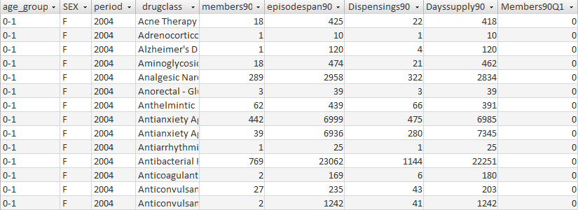

**Figure 12: Sample Incident Drug Category Summary Table**

## Incident Ingredient Name Summary Table

The incident name, also known as generic name, table provides a count of unique members with an incident dispensing for each generic drug name of interest stratified by age group, sex, and year. Incidence is defined as a member with a dispensing with the generic drug name of interest (i.e., the index date), in the year of interest with no evidence of a dispensing for that generic drug name in the 90, 180 and 270 days (i.e., the lookback periods)before the index date**.** Both medical and drug coverage are required during the 3 possible lookback periods, allowing for eligibility gaps of <=45 days. In addition to reporting the number of members with an incident dispensing, for each such incident user a treatment episode starting on the index date is being created, and the total number of dispensing with the generic name of interest, days supplied and length of treatment episodes (in days) in the 90, 180, 270 days after the index date are reported. Treatment gaps of <= 15 days are allowed when building treatment episodes and no restriction on the length of treatment episodes is applied. Although a member can have multiple index events in a given calendar year the first one only is counted and used for reporting.

The counts are stratified by generic drug name, age group, sex, and year. Ingredient names are standardized using a look-up table provided by the Mini-Sentinel Operations Center. For each stratum the results contain 3 separate sections for each of the 90, 180 and 270 lookup scenarios. Each section contains the total number of members, total dispensings, total days supplied and total length of all episodes, as well as a quarterly breakdown of index dates (must sum up to total number of members).

***Table name, variables, and permissible formats for the Incident Ingredient Name table:***

Summary table name: INCIDENT_GENERIC_NAME

Age_Group: ‘ 0-1’, ‘2-4’, ‘ 5- 9’, ’10-14’, ’15-18’, ’19-21’, ’22-44’, ’45-64’, ’65-74’, ‘75+ ‘ (character format)

Sex: ‘M’, ‘F’ (character format)

Period: 4 digit year (character format)

GenericName: 72 digit character format

Members (90-, 180-, 270-, by quarter): Numeric format

Dispensings (90-, 180-, 270-): Numeric format

Dayssupply (90-, 180-, 270-): Numeric format

EpisodeSpan (90-, 180-, 270-): Numeric format

MembersQ1 (90-, 180-, 270-): Numeric format

MembersQ2 (90-, 180-, 270-): Numeric format

MembersQ3 (90-, 180-, 270-): Numeric format

MembersQ4 (90-, 180-, 270-): Numeric format

Age_Group_ID: Numeric format

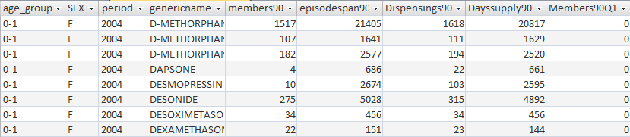

**Figure 13: Sample Incident Ingredient Name Summary Table**

# 5. Most Frequent Utilization Feature

The Most Frequent Utilization feature allows investigators to query the top XX events and members within a specified query type (drugs, diagnoses, or procedures) within the prevalence tables.

The counts are stratified by age group, sex, year, code/drug name or class, and for diagnoses and procedures, setting of visit (inpatient, outpatient, emergency department, or any).

# 6. Query Result Denominator

The Mini-Sentinel Distributed Query Tool results include counts of utilization and enrollment information for each stratum included in the query. The denominator information is obtained by extracting enrollment data from the enrollment table. For pharmacies queries the tool provides a count of all members who had drug coverage independent of medical coverage status. For medical care queries the denominator represents all members with medical care coverage regardless of drug coverage status.